### Project Name: Job Application Tracking System - (Developer)

### Team ID : LTVIP2024TMID11609

### Team Leader : S MOHAN

### Team member : S. SURENDRA

### User Adoption

**Create A Record(Recruiter)**

* Click on App Launcher on left side of screen.
* Search Job Application Tracking & click on it.
* Click on Recruiter Tab.
* Click new and fill details & Save

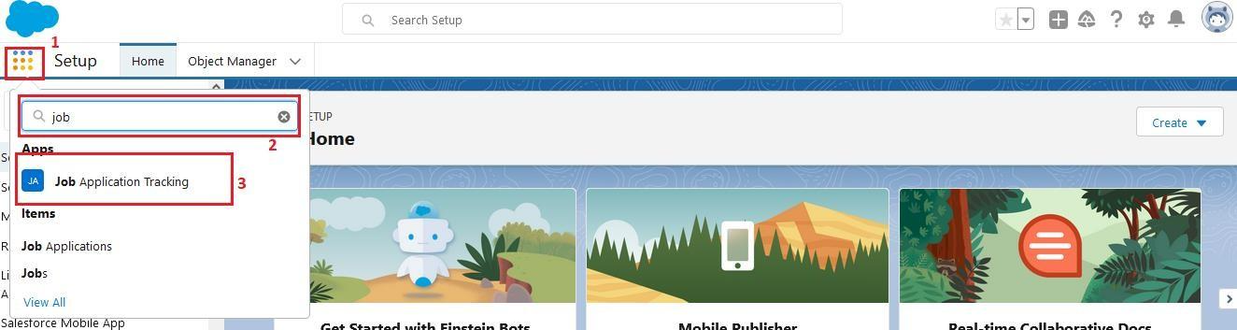

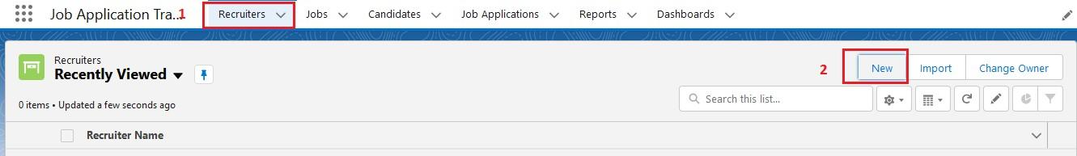

**View A Record(Recruiter)**

* Click on App Launcher on left side of screen.
* Search Job Application Tracking & click on it.
* Click on Recruiter Tab.
* Click on any record name. you can see the details of the Event.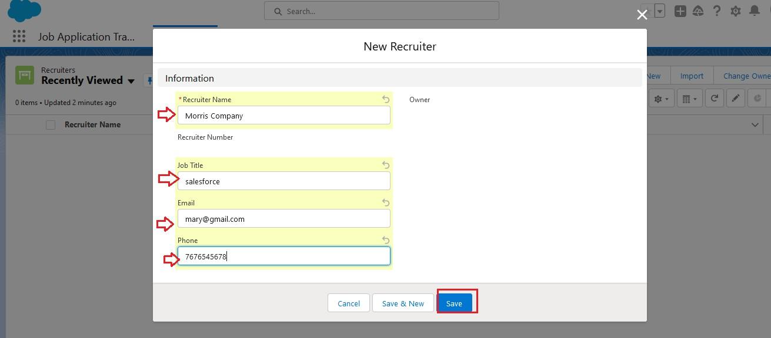

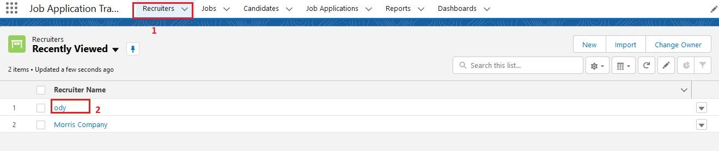

**Delete A Record(Recruiter)**

* Click on App Launcher on left side of screen.
* Search Job Application Tracking & click on it.
* Click on Recruiter Tab.
* Click on Arrow at right hand side on that Particular record.
* Click delete and delete again.

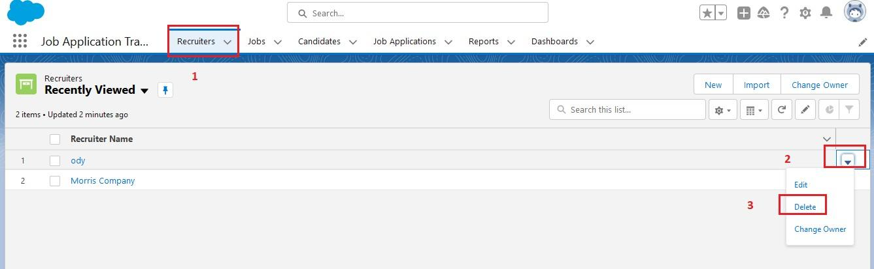

### Reports

**Create A Report**

Create a report that displays rating of the account and which has type and account name.

1.Click on app launcher search for reports.  
2.Click on the new report and select the category has job application with candidate name.

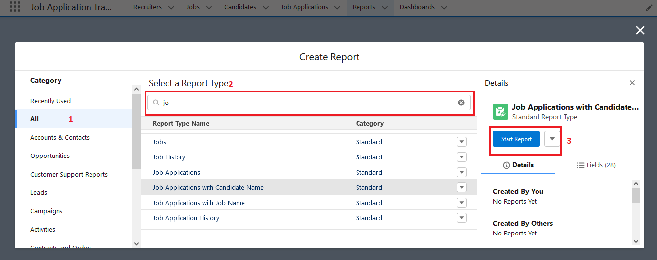

3.In the details section select the option start report.  
4.show me my job application and job application created date(All time)  
5.In the outline pane, group rows select job application created date.  
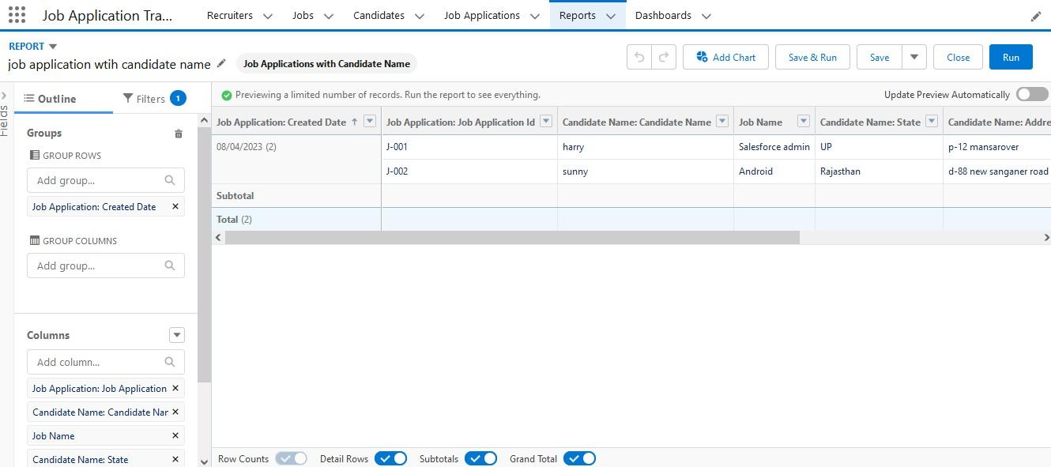

6.Save the report by giving label name(Job application wtih candidate name) and save the folder as a public folder and save the report.

**Create Another Report**

Create a Report using the Objects Jobs, Candidate and Job Application. Follow the steps from above Activity.